***Project: Coffee Sales Analysis***

***1. Project Objective***

*The primary objective of this project is to analyze the coffee sales of a company to better understand sales trends, identify improvement opportunities, and provide strategic recommendations. This project focuses on optimizing sales management using advanced Excel tools and functions.*

**2. Data Used**

The data includes:

* **Sales by Product**: Quantities of coffee sold by product type.
* **Unit Cost**: Selling price and cost per unit of each product.
* **Sales Dates**: Specific periods when sales occurred.

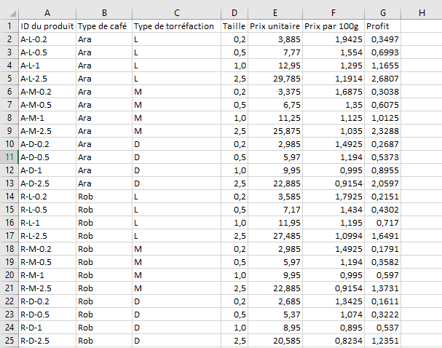

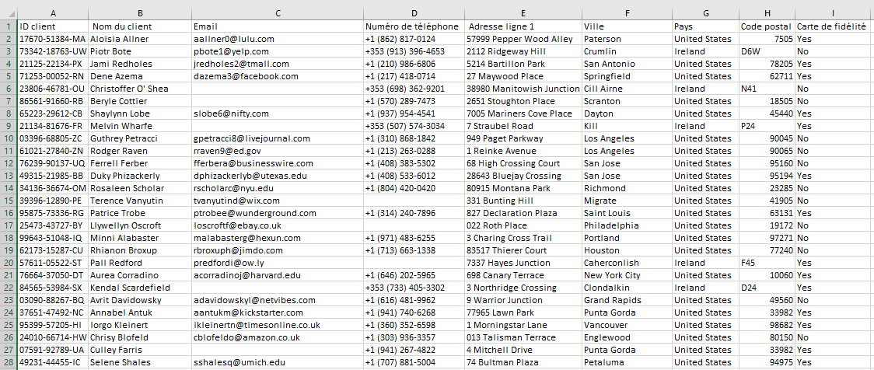

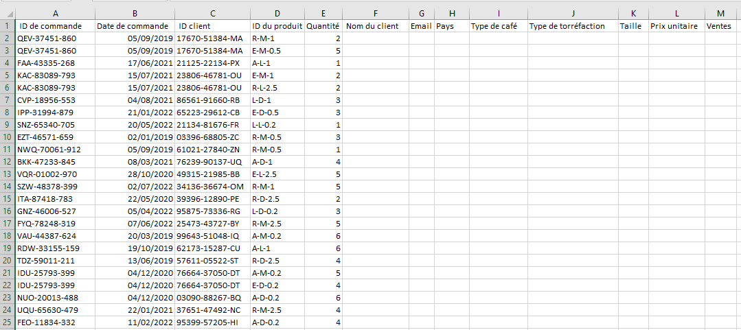

**3. Features Used**

a) **XLOOKUP and INDEX MATCH**

Used to search for specific information within large databases, such as linking sales to products or clients. These formulas allow for quick retrieval of important data, like product prices and quantities sold.

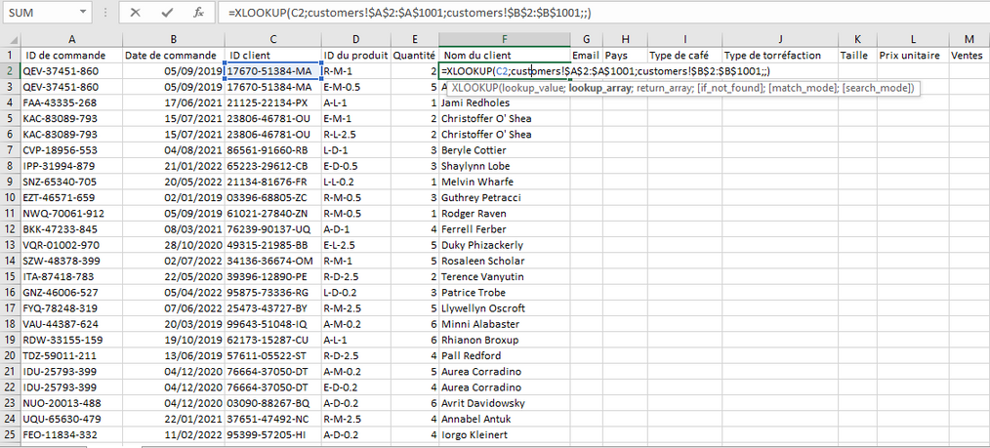

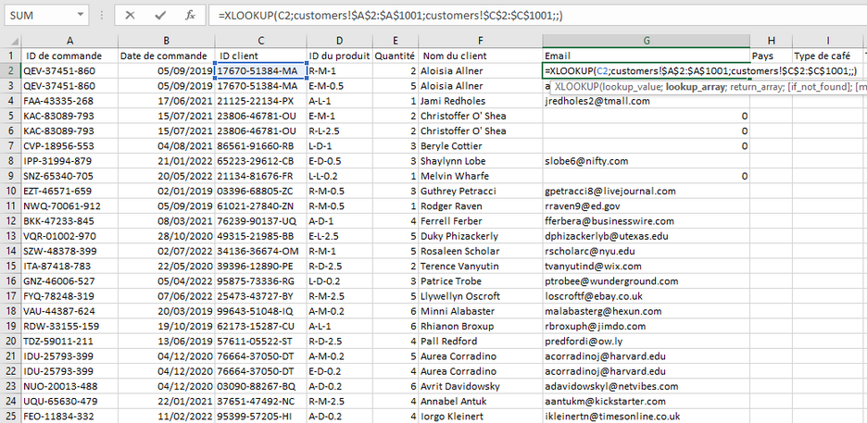

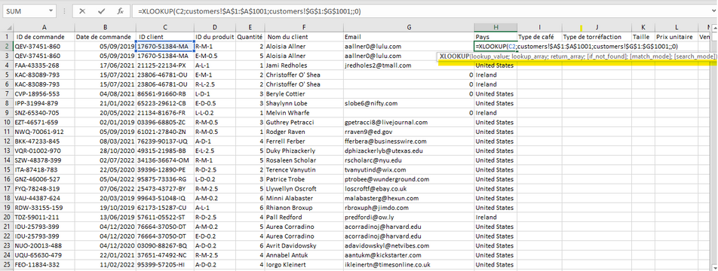

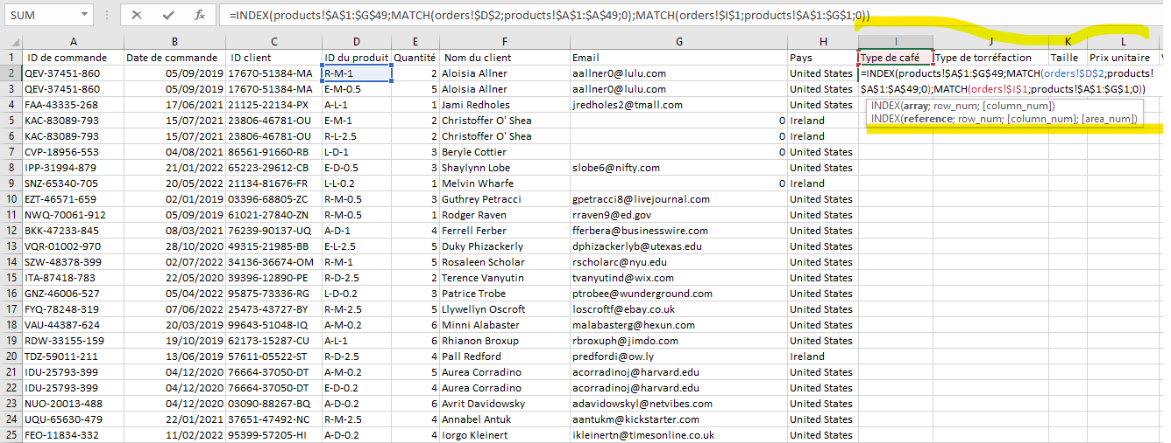

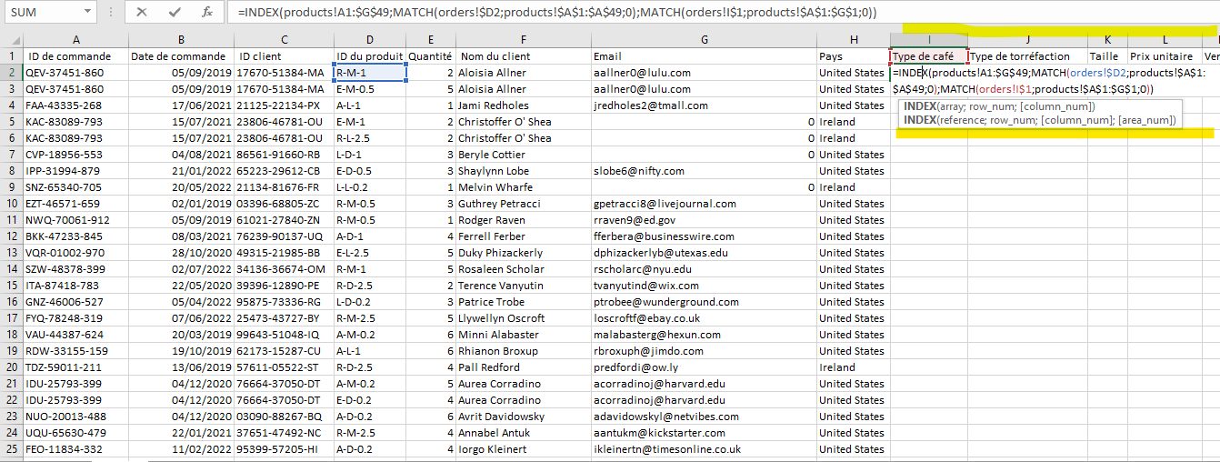

b) **Multiplication Formula for Sales**

A simple formula was used to calculate the total revenue by multiplying the number of units sold by the unit selling price.

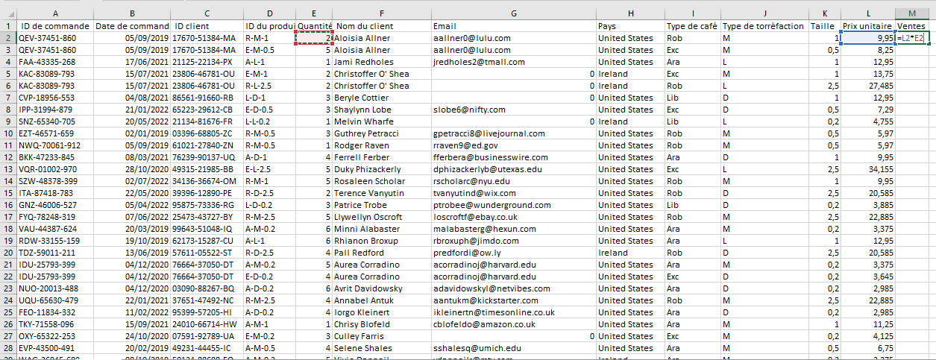

c) **Multiple IF Functions**

IF functions were used to define different conditions, such as calculating discounts or checking if sales meet certain thresholds.

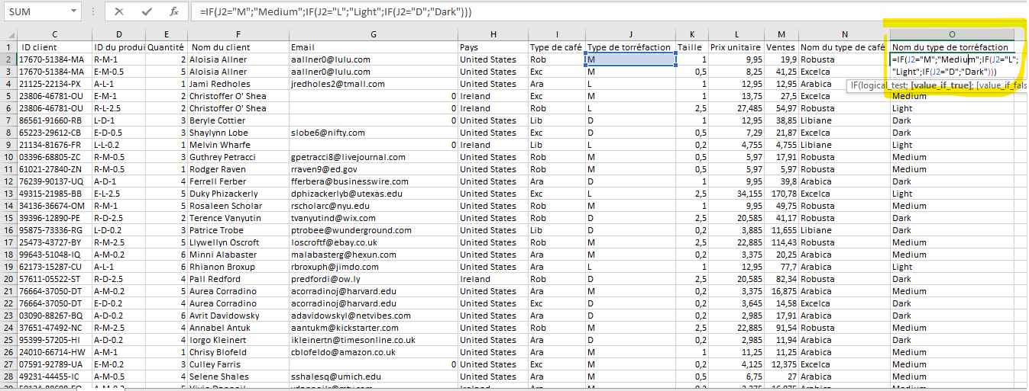

d) **Date and Number Formatting**

Specific formatting was applied to dates (days, months, years) to ensure a clearer reading of sales periods. Numbers (such as monetary amounts) were formatted to indicate currency values with separators and decimals.

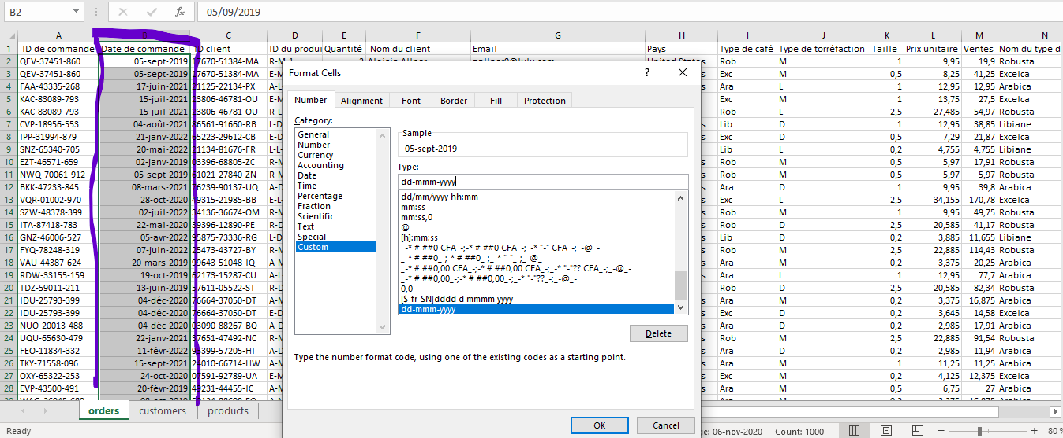

e) **Checking for Duplicates**

Duplicates in sales or product information were checked and removed to ensure data reliability.

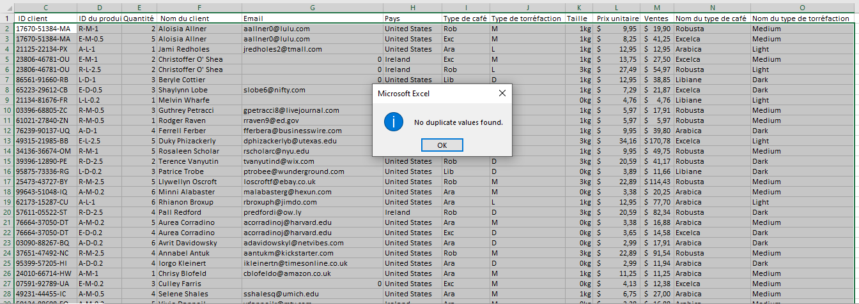

f) **Convert Range to Table**

All data was converted into a table to facilitate filter management and data sorting, making the analysis process more fluid and interactive.

**4. Analysis with Pivot Tables**

Pivot tables were used to group and summarize data by product, month, and client. They were used to:

* Visualize total sales by coffee type.
* Compare sales performance over time.
* Identify top clients or market segments.

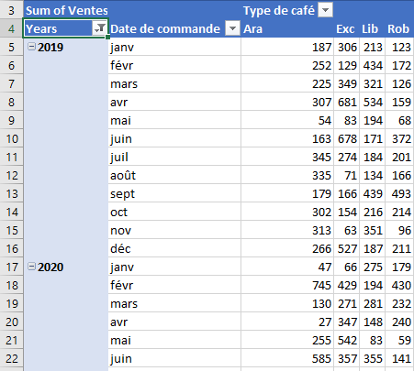

**Pivot Charts**

Pivot charts were created to visualize results dynamically and help decision-makers understand trends more easily.

**5. Dashboard**

An interactive dashboard was developed to track key performance indicators (KPIs) in real-time, including:

* Sales by product.
* Sales by month or quarter.
* Best product categories.
* Sales trends over time.

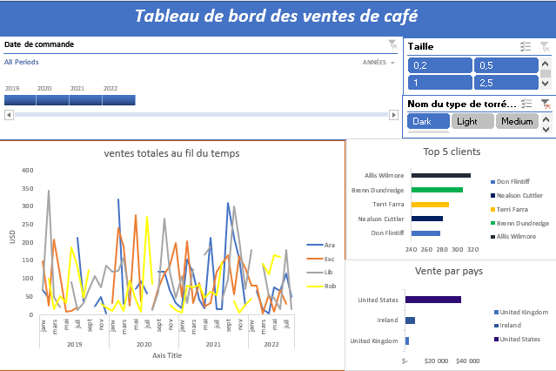

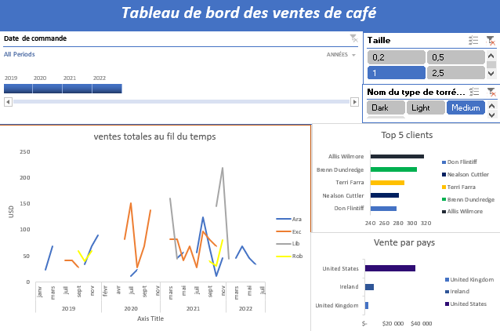

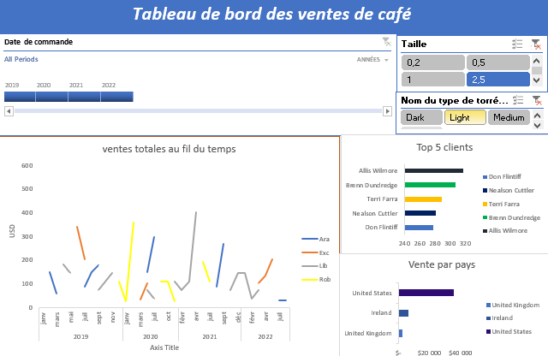

This dashboard includes **timelines** and **slicers** for interactive filtering and more precise analysis.

**6. Updating the Data Source**

The data sources for the pivot table were regularly updated to ensure the dashboard always reflected the most recent information available.

**7. Results and Recommendations**

The analysis highlighted the best-performing products and the most profitable sales periods. This led to recommendations:

* Increase sales of the most popular products.
* Adjust sales strategies for less effective products.
* Target historically lower sales periods with promotions or special offers.

**8. Challenges Encountered**

Some difficulties were encountered with managing duplicates in the data, but these were resolved using duplicate checking and data cleaning features.

**9. Conclusion**

The project provided a more strategic approach to sales analysis using Excel. The interactive dashboard offers a clear and comprehensive view of company performance, facilitating informed decision-making.